Seismic Operations During Cruise IMAGES VIII, MONA/PAGE 2002, D-1-02-GM Cruise of the R/V Marion Dufresne in the Northern Gulf of Mexico
Patrick E. Hart and Thomas D. Lorenson

High-resolution chirp seismic refection profiles were collected at most of the 2002 core sites using a hull-mounted Thales Sea Falcon II chirp seismic system, using a 25 ms chirp source with a 1600 Hz bandwidth centered at 3.75 kHz. The system was operating almost continuously during the cruise, recording approximately 600 files in standard geophysical 16-bit SEG-Y format, which were later concatenated into 12 larger files. The 40 SEG-Y files available on the USGS website, http://walrus.wr.usgs.gov/infobank/d/d102gm/html/d-1-02-gm.meta.html were taken from these 12 files and comprise the tracklines designed to pass through and adjacent to the coring sites. The final SEG-Y data files each contain a SEG-Y EBCDIC file header (shown below) listing important information about the data and the data trace headers. The most important trace header information is longitude and latitude, given as 4 byte integers in trace header locations bytes 191-194 and 195-198, respectively. The values are decimal degrees, with five decimal places, multiplied by 100,000 to allow the values to remain integer. For example, a latitude of 27.29863 degrees will be recorded in the trace header as 2729863.

Table 1. SEG-Y EBCDIC header.

**********************
* EBCDIC REEL HEADER *
**********************
C 1 U. S. GEOLOGICAL SURVEY COASTAL AND MARINE GEOLOGY TEAM
C 2 SURVEY_ID: D1-02-GM YEAR: 2002
C 3 AREA: NORTHERN GULF OF MEXICO VESSEL: R/V MARION DUFRESNE
C 4
C 5 INSTRUMENT: THALES UNDERWATER SYSTEMS SEAFALCON II CHIRP SEISMIC
C 6 25 MS CHIRP LENGTH 1600 HZ BANDWIDTH CENTERED AT 3.75KHZ
C 7 LINEAR FREQUENCY MODULATED CHIRP
C 8 RECORDING PARAMETERS: CHANNELS PER SHOT: 1
C 9 SAMPLE INTERVAL: 417 MICROSEC SAMPLE FREQUENCY: 2.4KHZ
C10 SAMPLES/TRACE: 2048 DATA LENGTH: 850 MSEC
C11 RECORD LENGTH VARIES WITH DEEP WATER DELAY PLUS DATA LENGTH
C12 DATA TRACE IS AMPLITUDE ENVELOPE; POSITIVE VALUES ONLY
C13
C14
C15 RECORDING FORMAT:
C16 SEG-Y 16-BIT INTEGER
C17 IMPORTANT TRACE HEADER VALUE LOCATIONS:
C18 NAME BYTES TYPE DESCRIPTION
C19 FFID 9-12 INTEGER FIELD FILE, SHOT OR PING NUMBER
C20 CDP 21-24 INTEGER SAME AS FFID
C21
C22 TYPE 29-30 INTEGER TRACE IDENTIFFICATION CODE
C23
C24
C25 DELAY 109-110 INTEGER DELAY RECORDING TIME IN MILLISEC
C26 NSAMPLES 115-116 INTEGER NUMBER OF SAMPLES IN THIS TRACE
C27 SRATE 117-118 INTEGER SAMPLE INTERVAL IN MICROSEC FOR THIS TRACE
C28 YEAR 157-158 INTEGER YEAR DATA RECORDED
C29 DAY 159-160 INTEGER DAY OF YEAR
C30 HOUR 161-162 INTEGER HOUR (24-HOUR CLOCK)
C31 MINUTE 163-164 INTEGER MINUTE
C32 SECOND 165-166 INTEGER SECOND
C33 LONGITUDE 191-194 INTEGER DECIMAL DEGREES TIMES 100000
C34 LATITUDE 195-198 INTEGER DECIMAL DEGREES TIMES 100000
C35
C36 FOR FURTHER INFORMATION CONCERNING THIS DATASET, CONTACT:
C37 PATRICK HART
C38 U. S. GEOLOGICAL SURVEY, M/S 999
C39 345 MIDDLEFIELD RD., MENLO PARK, CALIFORNIA 94025
C40 (650) 329-5160 INTERNET: HART@USGS.GOV

The SEG-Y data traces are the calculated amplitude envelope attribute showing positive values only, as opposed to a conventional wiggle trace with positive and negative values. The firing or chirp interval during data acquisition was 1.3 seconds for lines SP1b, SP2 and SP3 and 4.3 seconds for lines SP15 and SP16. For all other lines this interval was 3.5 seconds. Sample interval of the data is 417 microseconds with 2048 samples per trace, giving a data length of 850 milliseconds. The data were recorded with a variable deep-water delay calculated in real-time based on the water depth. In theory, this will give a constant record length below seafloor, but in practice the bottom-tracking feature occasionally loses the bottom and this causes skipped or blank traces in the final display. This is evident on some of the Tiff image files of the seismic lines, such as line SP15 or SP33a. The SEG-Y files are output with the deep-water delay applied.
In addition to the SEG-Y format files, a Tiff image file of each seismic line is available on the USGS website http://walrus.wr.usgs.gov/infobank/d/d102gm/html/d-1-02-gm.meta.html. These are grayscale Tiff format files with LZW compression. The display parameters of the data in these Tiff files are 15 inches/second and either 40 or 100 traces/inch. The horizontal scale is dependent on the chirp interval, ship speed and the traces/inch of the plot. To accurately determine horizontal distance along one of these seismic profiles, refer to the navigation file (D102GM_lines.xls) available on the USGS website http://walrus.wr.usgs.gov/infobank/d/d102gm/html/d-1-02-gm.meta.html. This spreadsheet lists position in decimal degrees versus time in GMT at 7 to 12 second intervals along each profile. A good estimate of horizontal scale for each line can be determined from the line summary table below, which lists line length and plotting parameters.
GMT is listed along the top of each seismic profile as hhmmss (hour,minute,second). Time is also in the standard SEG-Y trace header locations as described in the EBCDIC header. All of the profiles are plotted with north and west on the left. Two-way reflection time in 10 ms intervals is listed along the sides of the seismic profiles in the Tiff images. Using a seismic velocity of 1500 m/s, each 10 ms represents approximately 7.5 meters of sediment. A reduced image of line SP17, a west-to-east profile crossing Bush Hill, is shown below in Figure 2a.

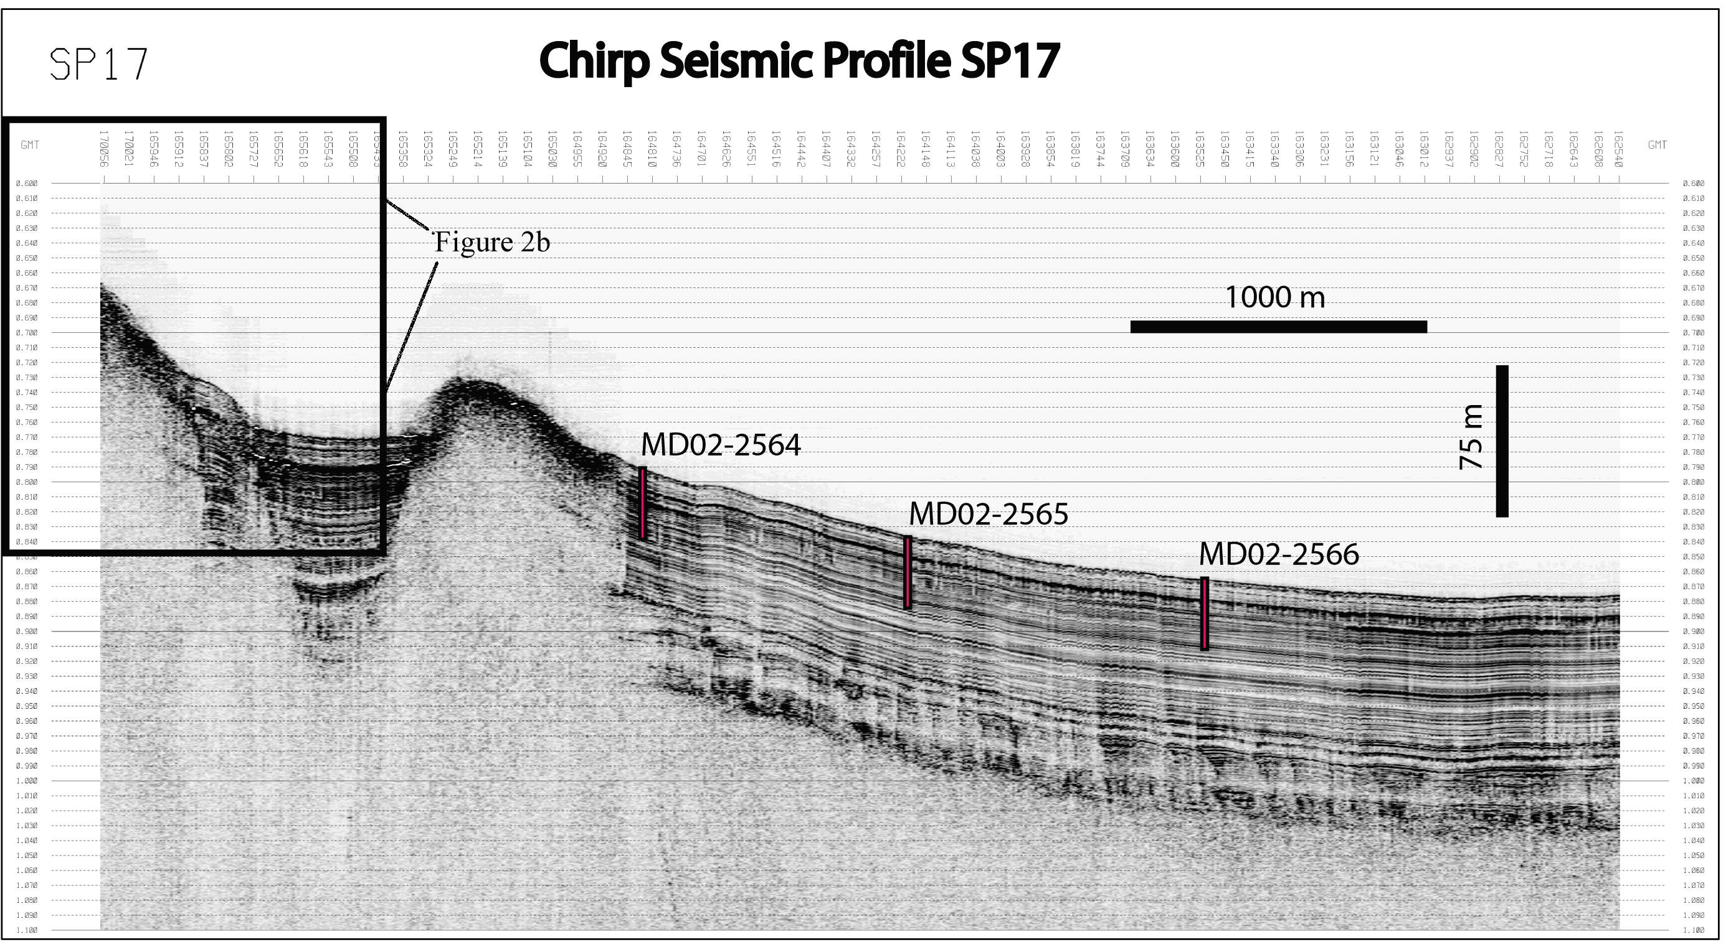

Fig. 2a. This image of seismic line SP17 was modified from the tiff image SP17.tif available on the USGS website http://walrus.wr.usgs.gov/infobank/d/d102gm/html/d-1-02-gm.meta.html. The size was reduced to fit on the page, and the title, scale bars, and the locations of cores MD02-2564, 2565, and 2566 were added. The data show good signal-to-noise ratio and approximately 100 to 150 m penetration into the soft sediments adjacent to the mound at the left-center of the figure. There is very little imaging beneath the hard carbonate and gas hydrate that occurs at the surface of this and similar mounds in the region. The location of this profile is shown on the Bush Hill map in Fig 4. At this reduced scale the GMT and two-way reflection time labels are not visible. The boxed area is expanded below in Figure 2b.

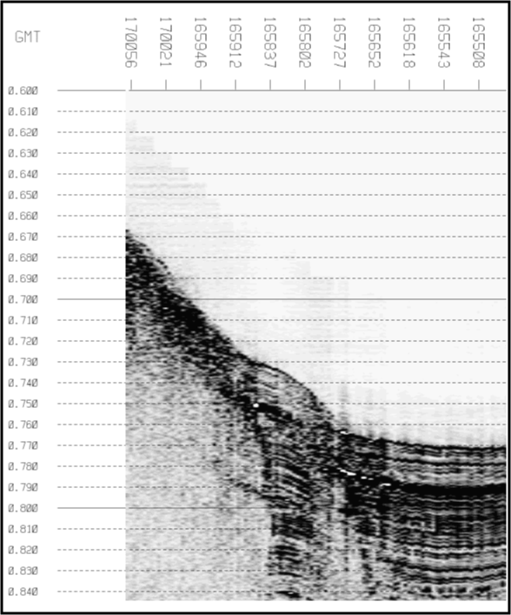

Figure 2b. This expanded view of a portion of line SP17 allows the GMT and reflection time labels to be read. Two-way reflection time from 600 ms to 840 ms in 10 ms intervals is labeled along the left and GMT from hour 16, minute 55, second 08 to hour 17, minute 00, second 56 is labeled along the top from right to left. The 35 second GMT label interval represents 10 traces at a 3.5 second chirp interval. This labeling is on all the Tiff image files.

Collecting geophysical data was not the highest cruise priority so the seismic coverage at each core site depends on the time available between coring operations. Trackline maps for the six areas where seismic data were acquired are shown in figures 3 through 8. The initial series of seismic lines at Tunica mound were poorly navigated and many lines were run in a fairly small area. As a result the lines are not straight and cross back and forth over each other. Figure 3a shows all the Tunica lines and figures 9b and 9c each plot a subset of the lines in order to be more legible. An additional problem with the Tunica lines is that the primary navigation recording system was not operating during the acquisition of lines SP1 to SP3, and lines SP6 through SP10. The navigation fixes for these lines were taken from the SEG-Y trace headers as described above. The precision of the fixes (approximately 10 m) in the trace headers is not as high as with the primary system (approximately 1 m) and therefore these lines appear to be choppier than the others when plotted at a large scale.
A table of information on all the chirp seismic lines is listed below and included on this CD in file “line_summary.xls”. Three of the recovered cores do not have corresponding chirp seismic lines that pass near their locations. For these cores, MD02-2566, 2567 and 2567, files were made of the chirp data recorded while the ship was drifting during coring operations. These are listed as lines 24d, 25d, and 33d.

Table 2. Chirp seismic reflection line summary

Line | Area | Length | JD | Start time | End time | Number | Tiff Scale | Line scale | Ave speed
no. |  | km |  | hour-min | hour-min | traces | inch/km | traces/km | kts
1a | Tunica Mound | 2.6 | 185 | 1812 | 1818 | 106 | 1.0 | 40.8 | 14.0
1b | Tunica Mound | 7.3 | 185 | 1818 | 1838 | 916 | 1.3 | 125.5 | 11.8
2 | Tunica Mound | 10.7 | 185 | 1841 | 1921 | 1850 | 1.7 | 172.9 | 8.7
3 | Tunica Mound | 4.6 | 185 | 1937 | 1956 | 856 | 1.9 | 186.1 | 7.8
4 | Tunica Mound | 2.8 | 186 | 403 | 422 | 861 | 3.1 | 307.5 | 4.8
5 | Tunica Mound | 3.6 | 186 | 433 | 500 | 1227 | 3.4 | 340.8 | 4.3
6 | Tunica Mound | 4.1 | 187 | 910 | 938 | 483 | 2.9 | 117.8 | 4.7
7 | Tunica Mound | 3.0 | 187 | 941 | 959 | 311 | 2.6 | 103.7 | 5.4
8 | Tunica Mound | 2.5 | 187 | 1228 | 1246 | 309 | 3.1 | 123.6 | 4.5
9 | Tunica Mound | 2.1 | 187 | 1252 | 1304 | 207 | 2.5 | 98.6 | 5.7
10 | Tunica Mound | 2.2 | 187 | 1312 | 1328 | 274 | 3.1 | 124.5 | 4.5
11 | Tunica Mound | 2.2 | 187 | 1344 | 1358 | 241 | 2.7 | 109.5 | 5.1
12 | Tunica Mound | 1.0 | 187 | 1423 | 1431 | 138 | 3.5 | 138.0 | 4.0
13 | Tunica Mound | 1.2 | 187 | 1439 | 1446 | 121 | 2.5 | 100.8 | 5.6
14 | Tunica Mound | 2.1 | 187 | 1653 | 1731 | 656 | 7.8 | 312.4 | 1.8
15 | Pigmy Basin | 6.7 | 190 | 537 | 620 | 603 | 2.3 | 90.0 | 5.0
16 | Pigmy Basin | 5.4 | 190 | 644 | 716 | 449 | 2.1 | 83.1 | 5.5
17 | Bush Hill | 6.0 | 190 | 1625 | 1701 | 610 | 2.5 | 101.7 | 5.4
18 | Bush Hill | 3.0 | 190 | 1722 | 1739 | 293 | 2.4 | 97.7 | 5.7
19 | Bush Hill | 2.8 | 190 | 1746 | 1802 | 276 | 2.5 | 98.6 | 5.7
20 | Bush Hill | 2.2 | 190 | 1813 | 1828 | 259 | 2.9 | 117.7 | 4.8
21a | Kane Spur | 21.0 | 192 | 444 | 646 | 2001 | 1.0 | 95.3 | 5.9
21b | Kane Spur | 19.3 | 192 | 935 | 1120 | 1811 | 0.9 | 93.8 | 6.0
22a | Kane Spur | 9.6 | 192 | 1224 | 1326 | 1070 | 1.1 | 111.5 | 5.0
22b | Kane Spur | 26.4 | 192 | 1650 | 1919 | 2569 | 1.0 | 97.3 | 5.7
23a | Kane Spur | 31.1 | 193 | 35 | 308 | 2639 | 0.8 | 84.9 | 6.6
23b | Kane Spur | 5.5 | 193 | 530 | 604 | 580 | 1.1 | 105.5 | 5.2
24 | Kane Spur | 27.4 | 193 | 649 | 908 | 2398 | 0.9 | 87.5 | 6.4
24d | Kane Spur | drift | 194 | 900 | 930 | 517 | drift | drift | drift
25 | Kane Spur | 23.0 | 194 | 342 | 542 | 2067 | 0.9 | 89.9 | 6.2
25d | Kane Spur | drift | 194 | 1457 | 1527 | 485 | drift | drift | drift
26 | West MC | 10.8 | 195 | 622 | 722 | 1035 | 1.0 | 95.8 | 5.8
27 | West MC | 4.8 | 195 | 1220 | 1252 | 552 | 1.2 | 115.0 | 4.9
28 | West MC | 6.0 | 195 | 1303 | 1340 | 638 | 1.1 | 106.3 | 5.3
29 | West MC | 10.7 | 195 | 1925 | 2023 | 1000 | 0.9 | 93.5 | 6.0
30 | West MC | 11.1 | 195 | 2035 | 2143 | 1172 | 1.1 | 105.6 | 5.3
31 | West MC | 6.6 | 195 | 2149 | 2225 | 621 | 0.9 | 94.1 | 5.9
32 | Central MC | 6.4 | 195 | 219 | 242 | 396 | 0.6 | 61.9 | 9.0
32d | Central MC | drift | 195 | 335 | 405 | 517 | drift | drift | drift
33a | Central MC | 9.5 | 196 | 37 | 105 | 483 | 0.5 | 50.8 | 11.0
33b | Central MC | 0.9 | 196 | 212 | 250 | 655 | 7.3 | 727.8 | 0.8

The two tables below are a summary of all the Marion Dufresne cores and are combined in the spreadsheet file on this CD “core_seismic.xls”. The one or two chirp seismic lines that pass over or near each core are listed with the core location along the line in time (GMT).

Table 3. Seismic reflection line ties with core locations.

CORE ID | Latitude | Longitude | Chirp Seismic Tie 1 | Chirp Seismic Tie 2
 |  |  | distance from line to core | distance from line to core
MD02-2535 | 27.61983 | -92.24100 | SP2; 185 190955; 10 m N | SP11; 187 135555; on line
MD02-2536GHF-1 | 27.62268 | -92.24378 | SP12;187 142955; on line | SP8; 187 123210; 20 m NW
MD02-2536GHF-2 | 27.62530 | -92.24600 | SP12; 187 143100; 220 m NW | none
MD02-2536GHF-3 | 27.62700 | -92.23750 | SP7; 187 95640; 170 m N | none
ΜΔ02−2537 | 27.61600 | -92.24867 | SP1a; 185 181435; on line | SP2; 185 191310; 30 m NW
MD02-2538G | 27.61667 | -92.24717 | SP1a; 185 181500; 20 m N | SP2; 185 191235; 30 m N
MD02-2539 | 27.63983 | -92.19226 | SP2; 185 184940; 80 m N | none
MD02-2540GHF-1 | 27.64008 | -92.19201 | SP2; 185 184935; 100 m N | none
MD02-2540GHF-2 | 27.64017 | -92.19533 | SP2; 185 185050; 190 m N | none
MD02-2541 | 27.63244 | -92.21245 | SP2; 185 185750; 160 m NW | none
MD02-2542GHF | 27.63212 | -92.21242 | SP2; 185 185750; 140 m NW | none
MD02-2543G | 27.61253 | -92.25565 | SP1a; 185 181250; 50 m SE | none
MD02-2544G | 27.61315 | -92.25336 | SP10; 187 132425; 20 m N | SP2; 185 191520; 30 m N
MD02-2545G | 27.61416 | -92.25177 | SP10 187 132255; on line | SP2; 185 191435; 20 m NW
MD02-2546 | 27.61567 | -92.24697 | SP11; 187 135125; 30 m SE | SP2; 185 191245; 80 m SE
MD02-2547GHF | 27.61642 | -92.24832 | SP1a; 185 181445; 30 m NW | SP2; 185 191300; 60 m NW
MD02-2553C2 | 27.18340 | -91.41694 | SP15; 190 55650; on line | SP16; 190 65950; 40 m N
MD02-2554 | 27.78371 | -91.49967 | SP17; 190 164820; on line | SP18; 190 172810; 50 m E
MD02-2555 | 27.78320 | -91.48901 | SP17; 190 164210; 50 m S | SP19; 190 175540; on line
MD02-2556 | 27.78300 | -91.47809 | SP17; 190 163520;90 m S | SP20; 190 182010; 30 m W
MD02-2557GHF1 | 27.78304 | -91.49862 | SP17; 190 164740; 70 m S | SP18; 190 172830; 150 m E
MD02-2557GHF2 | 27.78310 | -91.48904 | SP17; 190 164210; 50 m S | SP19; 190 175540; on line
MD02-2557GHF3 | 27.78288 | -91.47720 | SP17; 190 163445; 100 m S | SP20; 190 182015; 50 m E
MD02-2559 | 28.22267 | -89.08784 | SP21a; 192 62815; on line | SP25; 194 53730; 60 m SE
MD02-2560 | 28.24361 | -89.15503 | SP21a; 192 54910; 40 m N | none
MD02-2561 | 28.20530 | -89.02016 | SP21b; 192 100640; 20 m N | SP23a; 193 13540; 20 m NW
MD02-2562 | 28.07997 | -89.14030 | SP23a; 193 30800; 170 m SW | none
MD02-2563C2 | 28.12354 | -89.13651 | SP24; 193 72140; 230 m N | none
MD02-2564GHFa | 28.24347 | -89.15464 | SP21a; 192 54925; 40 m N | none
MD02-2564GHFb | 28.22257 | -89.08861 | SP25; 194 53710; 10 m SE | SP21a; 192 62755; 50 m SW
MD02-2564GHFc | 28.20545 | -89.02014 | SP21b; 192 100640; 30 m N | SP23a; 193 13535; 30 m NW
MD02-2564GHFd | 28.20733 | -89.02019 | SP23a; 193 13450; 170 m NW | none
MD02-2565 | 28.12361 | -89.13971 | SP24; 193 72000; 130 m N | none
MD02-2566 | 28.11927 | -89.10339 | SP23a; 193 235 30; 660 m NW | SP24d; 194 91630; on line
MD02-2567 | 28.10037 | -89.02007 | SP24; 193 82700; 1750 m NE | SP25d; 194 151730; on line
MD02-2568GHFa | 28.07992 | -89.14030 | SP23a; 193 30800; 170 m SW | none
MD02-2568GHFb | 28.08107 | -89.13717 | SP23a; 193 30610; 100 m SE | none
MD02-2568GHFc | 28.11936 | -89.10331 | SP23a; 193 235 30; 660 m NW | SP24d; 194 92850; on line
MD02-2568GHFd | 28.12347 | -89.13952 | SP24; 193 72010; 120 m N | none
MD02-2568GHFe | 28.12354 | -89.13636 | SP24; 193 72150; 240 m N | none
MD02-2569 | 28.15218 | -89.47980 | SP33b; 196 21200; 20 m SW | SP32d; 195 33800; on line
MD02-2570 | 28.07107 | -89.68997 | SP26; 195 65720; 20 m S | SP31; 195 222450; 60 m NW
MD02-2571C2 | 28.06681 | -89.72007 | SP26; 195 64020; 90 m S | SP28; 195 132315; 150 m W
MD02-2572GHF | 28.07109 | -89.69001 | SP26; 195 65720; 20 m S | SP31; 195 222450; 60 m NW
MD02-2573GHF | 28.15204 | -89.48004 | SP33b; 196 21200; 50 m SW | SP32d; 195 34200; on line

Table 4. Recovered core summary

CORE ID | Latitude | Longitude | Site Name | Core Length | Water Depth
 |  |  |  | meters | meters
MD02-2535 | 27.61983 | -92.24100 | Tunica Mound | 37.84 | 605
MD02-2536GHF-1 | 27.62268 | -92.24378 | Tunica Mound | 8.88 | 608
MD02-2536GHF-2 | 27.62530 | -92.24600 | Tunica Mound | none | 564
MD02-2536GHF-3 | 27.62700 | -92.23750 | Tunica Mound | none | 585
ΜΔ02−2537 | 27.61600 | -92.24867 | Tunica Mound | 33.58 | 600
MD02-2538G | 27.61667 | -92.24717 | Tunica Mound | 7.76 | 599
MD02-2539 | 27.63983 | -92.19226 | Tunica Mound | 31.10 | 622
MD02-2540GHF-1 | 27.64008 | -92.19201 | Tunica Mound | 5.65 | 617
MD02-2540GHF-2 | 27.64017 | -92.19533 | Tunica Mound | none | 620
MD02-2541 | 27.63244 | -92.21245 | Tunica Mound | 35.34 | 615
MD02-2542GHF | 27.63212 | -92.21242 | Tunica Mound | 7.70 | 617
MD02-2543G | 27.61253 | -92.25565 | Tunica Mound | 0.15 | 579
MD02-2544G | 27.61315 | -92.25336 | Tunica Mound | 0.10 | 584
MD02-2545G | 27.61416 | -92.25177 | Tunica Mound | 9.27 | 588
MD02-2546 | 27.61567 | -92.24697 | Tunica Mound | 31.21 | 595
MD02-2547GHF | 27.61642 | -92.24832 | Tunica Mound | 5.73 | 607
MD02-2553C2 | 27.18340 | -91.41694 | Pigmy Basin | 10.32 | 2259
MD02-2554 | 27.78371 | -91.49967 | Bush Hill | 31.05 | 602
MD02-2555 | 27.78320 | -91.48901 | Bush Hill | 35.68 | 636
MD02-2556 | 27.78300 | -91.47809 | Bush Hill | 34.25 | 654
MD02-2557GHF1 | 27.78304 | -91.49862 | Bush Hill | 5.59 | 613
MD02-2557GHF2 | 27.78310 | -91.48904 | Bush Hill | none | 639
MD02-2557GHF3 | 27.78288 | -91.47720 | Bush Hill | none | 659
MD02-2559 | 28.22267 | -89.08784 | Kane Spur | 33.39 | 1132
MD02-2560 | 28.24361 | -89.15503 | Kane Spur | 28.24 | 1029
MD02-2561 | 28.20530 | -89.02016 | Kane Spur | 28.80 | 1268
MD02-2562 | 28.07997 | -89.14030 | Kane Spur | 26.09 | 1051
MD02-2563C2 | 28.12354 | -89.13651 | Kane Spur | 3.86 | 1070
MD02-2564GHFa | 28.24347 | -89.15464 | Kane Spur | 7.63 | 1027
MD02-2564GHFb | 28.22257 | -89.08861 | Kane Spur | none | 1261
MD02-2564GHFc | 28.20545 | -89.02014 | Kane Spur | none | 1269
MD02-2564GHFd | 28.20733 | -89.02019 | Kane Spur | none | 1269
MD02-2565 | 28.12361 | -89.13971 | Kane Spur | 22.50 | 1068
MD02-2566 | 28.11927 | -89.10339 | Kane Spur | 26.05 | 1186
MD02-2567 | 28.10037 | -89.02007 | Kane Spur | 26.65 | 1318
MD02-2568GHFa | 28.07992 | -89.14030 | Kane Spur | 6.96 | 1049
MD02-2568GHFb | 28.08107 | -89.13717 | Kane Spur | none | 1057
MD02-2568GHFc | 28.11936 | -89.10331 | Kane Spur | none | 1190
MD02-2568GHFd | 28.12347 | -89.13952 | Kane Spur | none | 1068
MD02-2568GHFe | 28.12354 | -89.13636 | Kane Spur | none | 1049
MD02-2569 | 28.15218 | -89.47980 | Central Miss | 10.35 | 1032
MD02-2570 | 28.07107 | -89.68997 | West MC | 28.35 | 631
MD02-2571C2 | 28.06681 | -89.72007 | West MC | 10.38 | 664
MD02-2572GHF | 28.07109 | -89.69001 | West MC | 4.90 | 628
MD02-2573GHF | 28.15204 | -89.48004 | Central MC | 4.20 | 1027

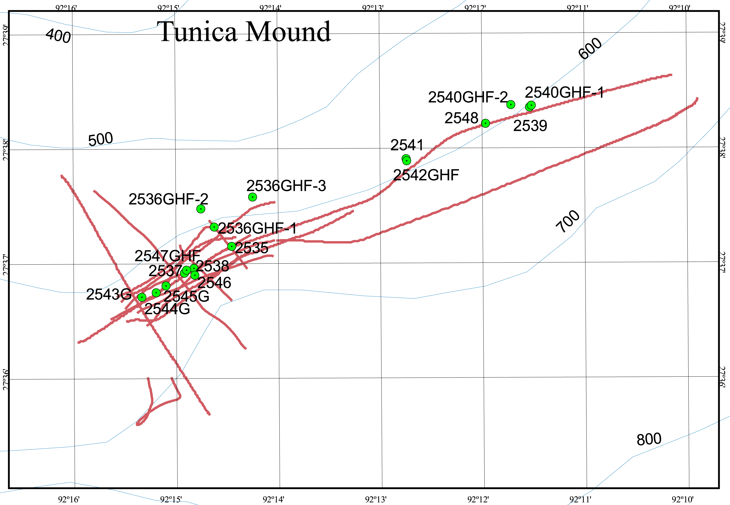

Figure 3a. Trackline map for seismic profiles at the Tunica Mound core sites. Core IDs are shown in this figure but line numbers are not, because the line spacing is too close to legibly show all line numbers in one page-size figure. Figures 3b and 3c show lines 1 through 7, and 8 through 14, respectively. Depth contours are in meters for this and all following maps.

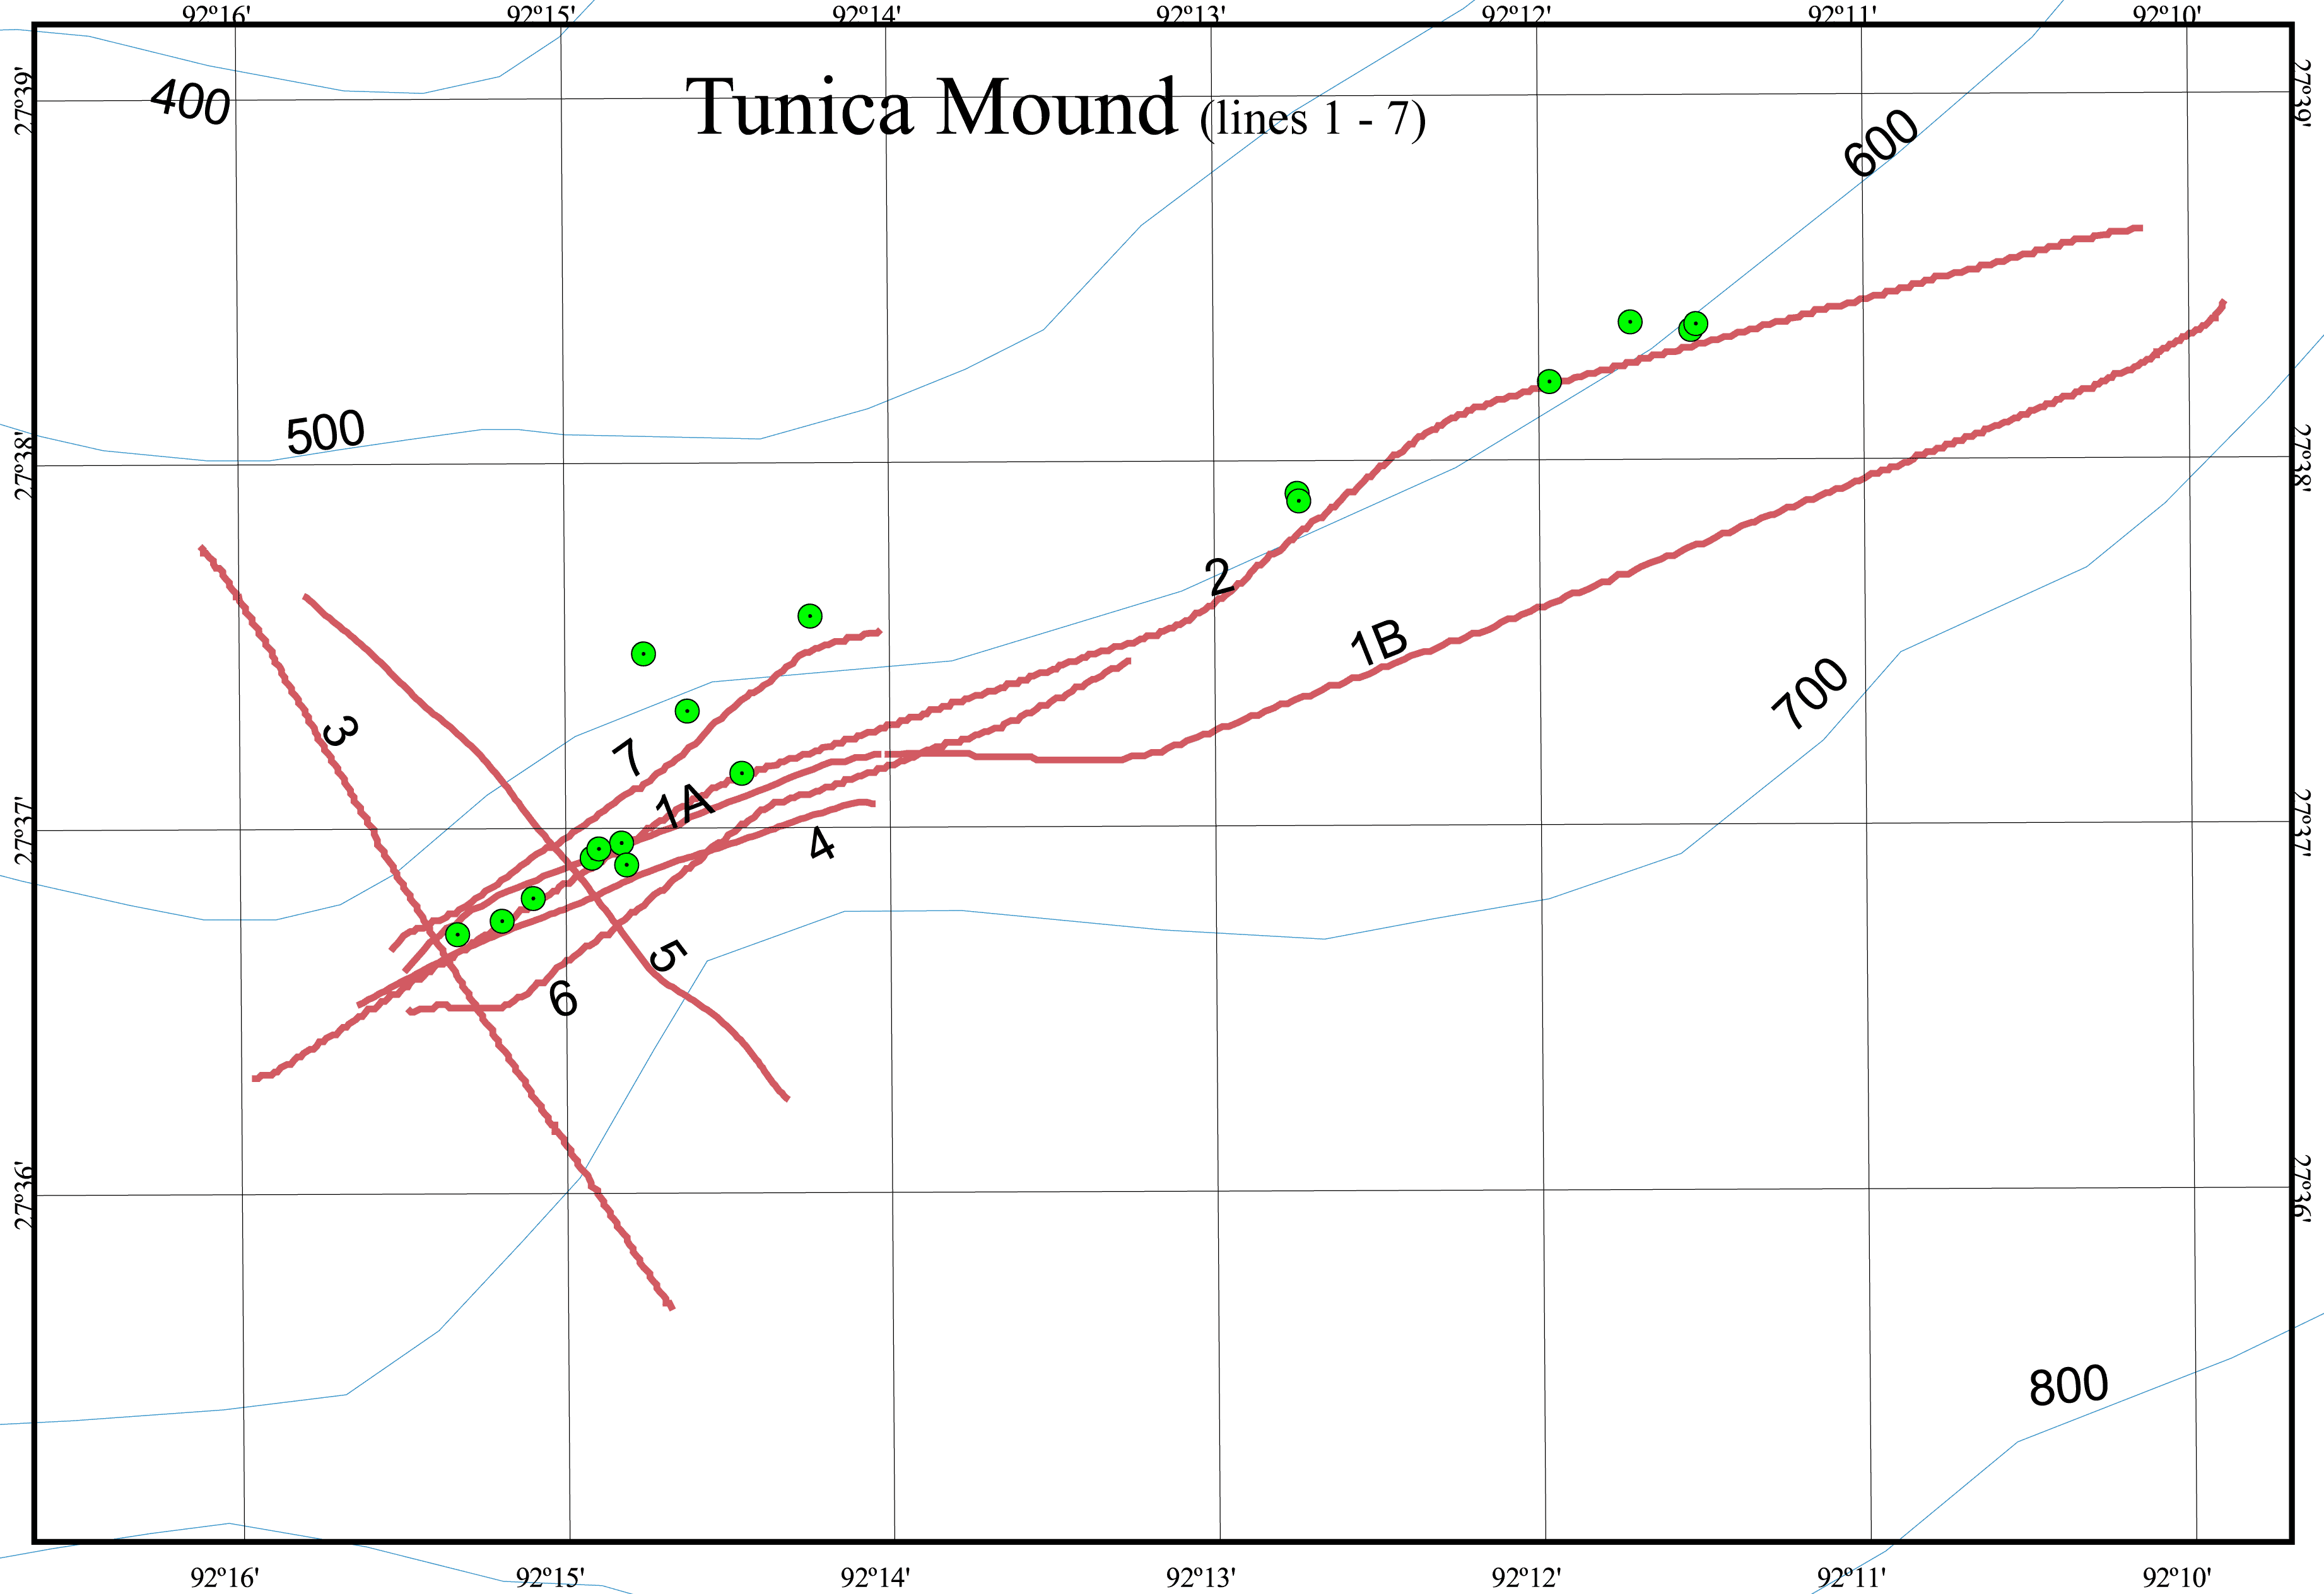

Figure 3b. Trackline map for seismic profiles 1 through 7 at the Tunica Mound core sites.

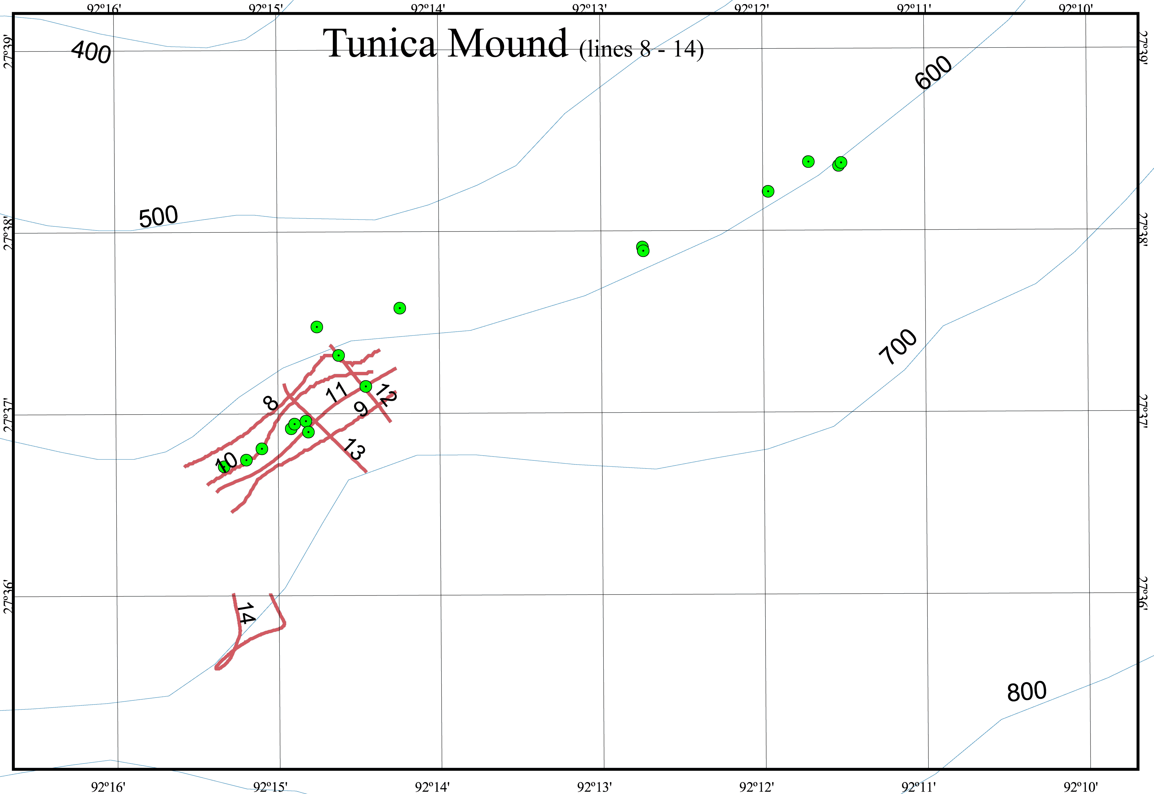

Figure 3c. Trackline map for seismic profiles 8 through 14 at the Tunica Mound core sites.

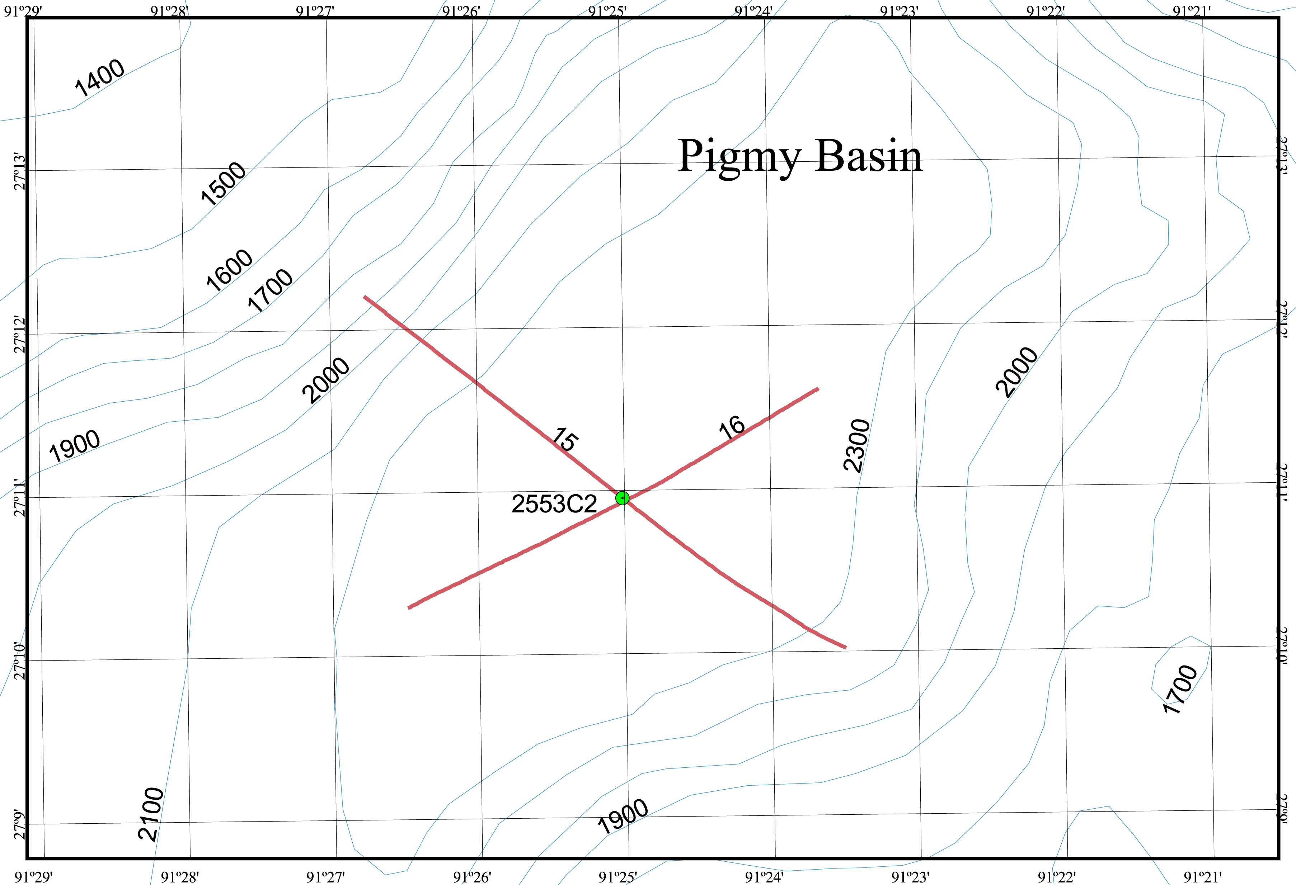

Figure 4. Trackline map for seismic profiles at the Pigmy Basin core site.

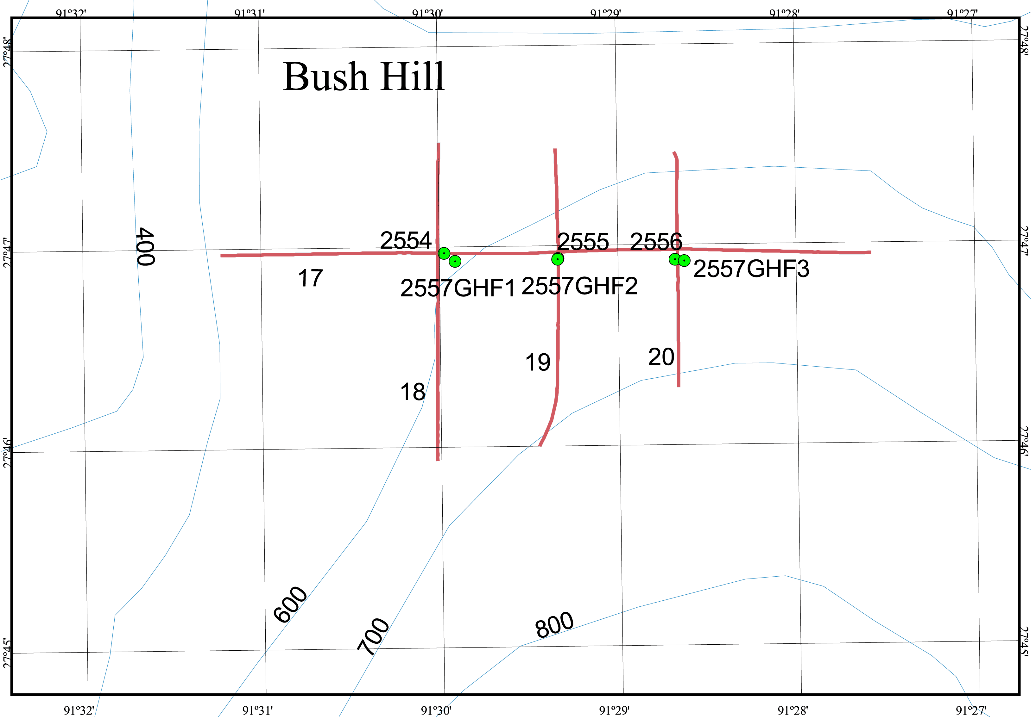

Figure 5. Trackline map for seismic profiles at the Bush Hill core sites.

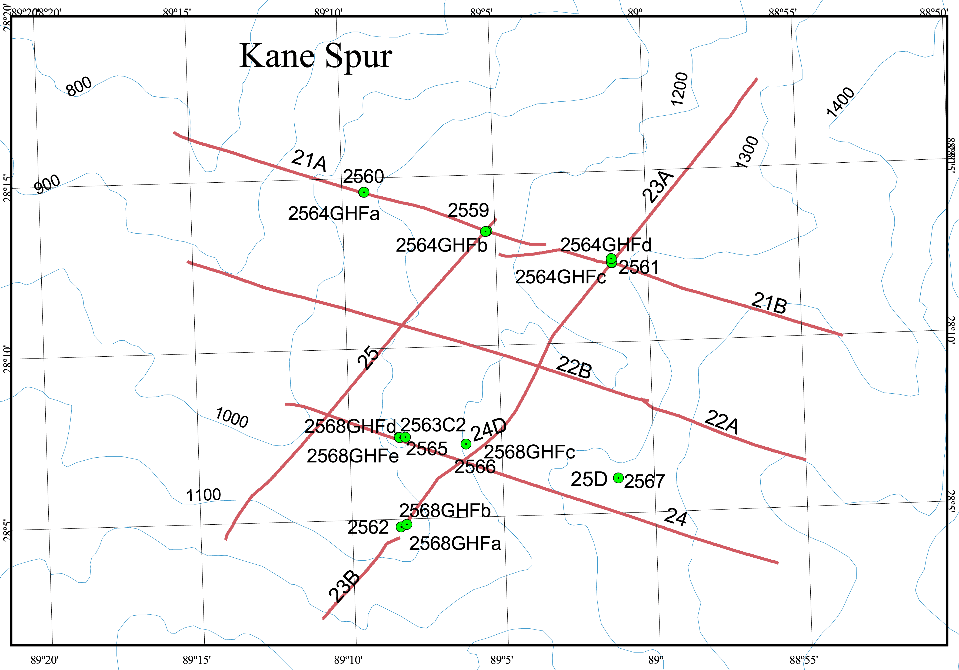

Figure 6. Trackline map for seismic profiles at the Kane Spur core sites in the eastern Mississipi Canyon.

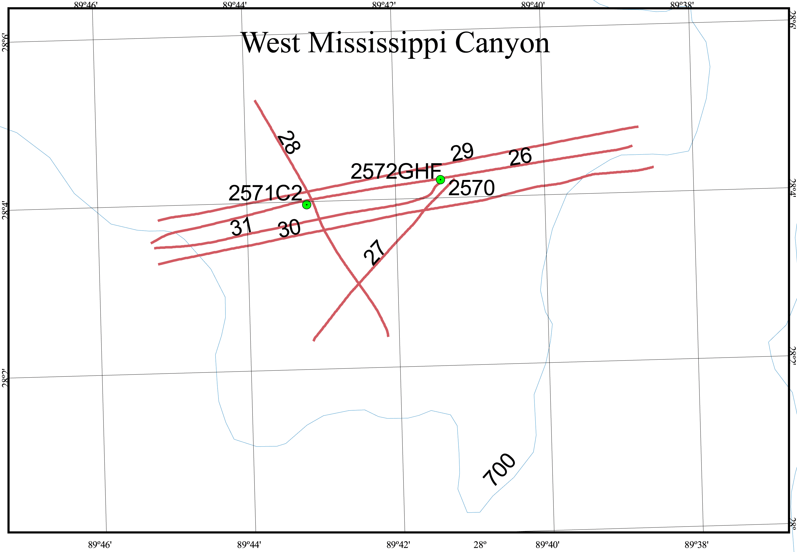

Figure 7. Trackline map for seismic profiles at the West Mississippi core sites.

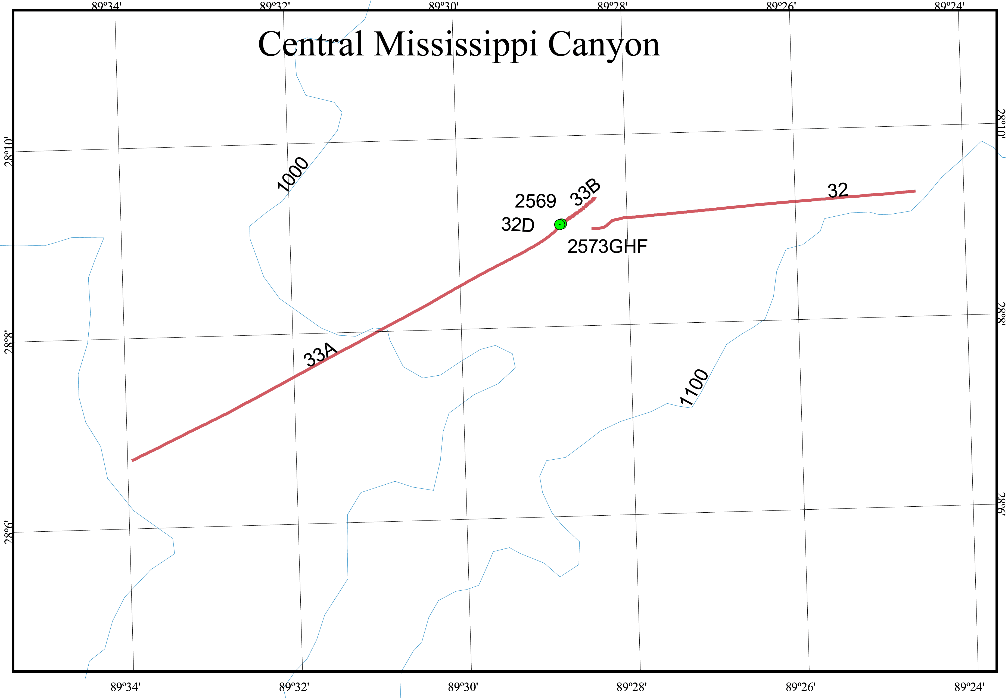

Figure 8. Trackline map for seismic profiles at the Central Mississippi core sites.

